**Name: احمد حمدي فاروق دسوقي الدولة**

**B.N: 51**

**Date: 27/5/2020**

**Topic: Artificial Intelligence**

**GitHub link :** [**https://github.com/ahmedeldola/ECE001**](https://github.com/ahmedeldola/ECE001)

**GitHub page:** [**https://ahmedeldola.github.io/ECE001/index.html**](https://ahmedeldola.github.io/ECE001/index.html)

**Application brief:**

Artificial intelligence is one of the most important topics in life now. We must give it great importance. Artificial intelligence has many applications, including:

**.** autonomous vehicles (such as drones and self-driving cars).

**.** medical diagnosis. **.** creating art (such as poetry).

**.** proving mathematical theorems **.** playing games (such as Chess).

**.** search engines (such as Google search)

• online assistants (such as Siri)

• image recognition in photographs spam filtering targeting online advertisements

• Telecommunications maintenance

• Online and telephone customer services

**Screenshot :**

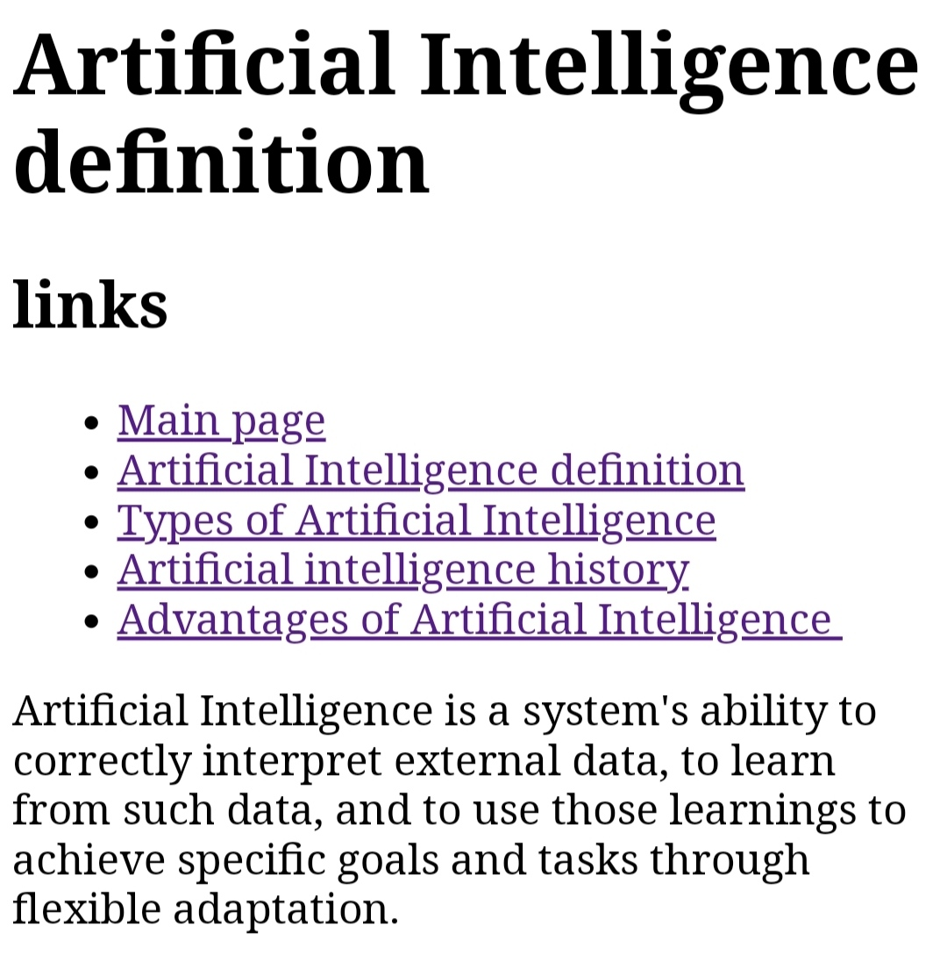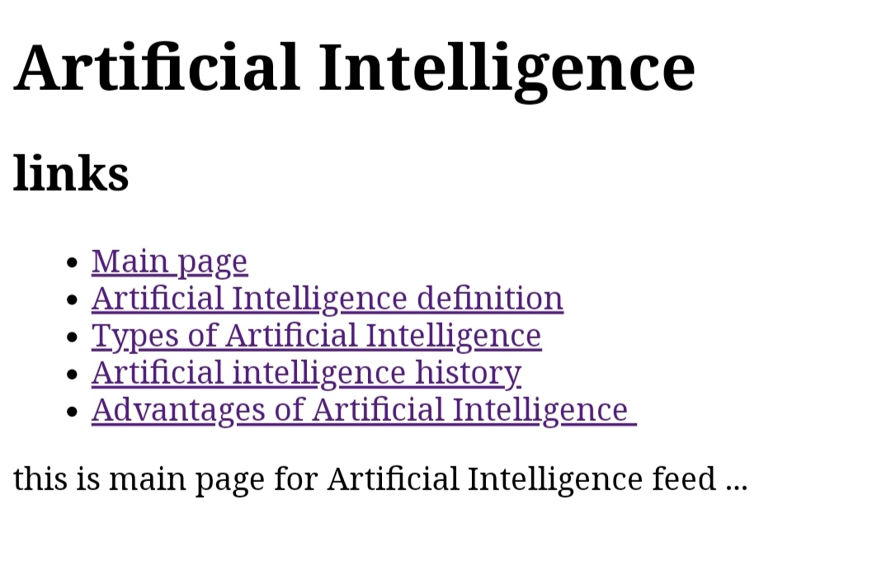

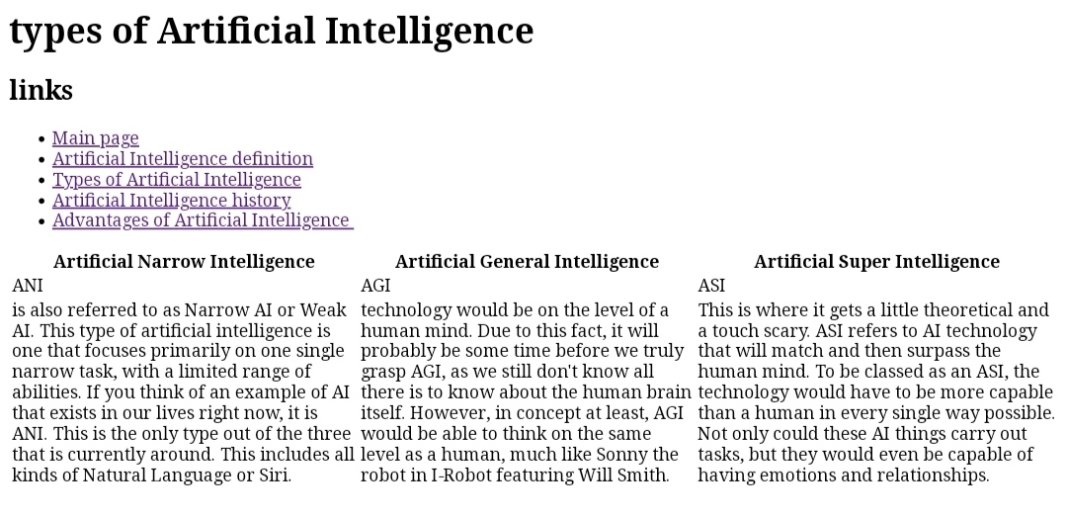

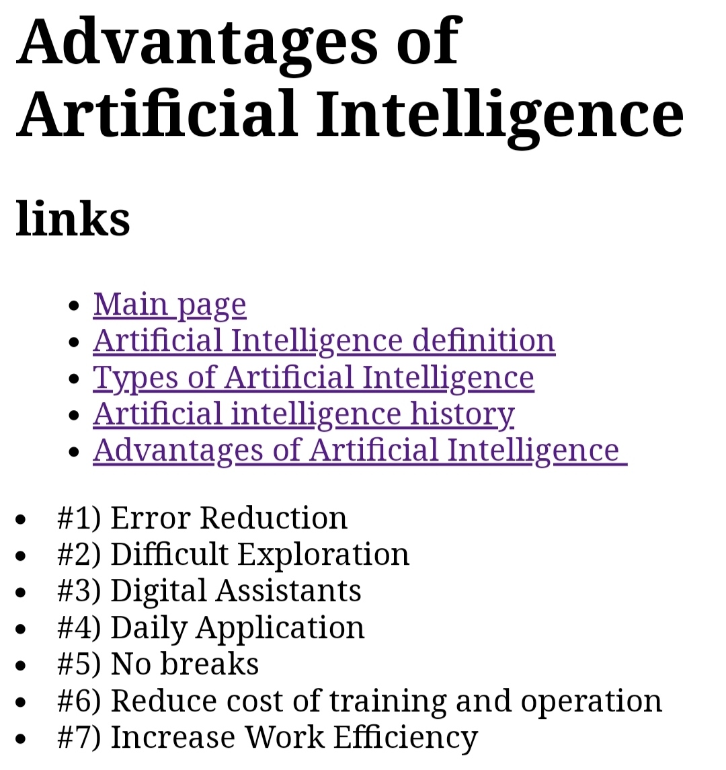

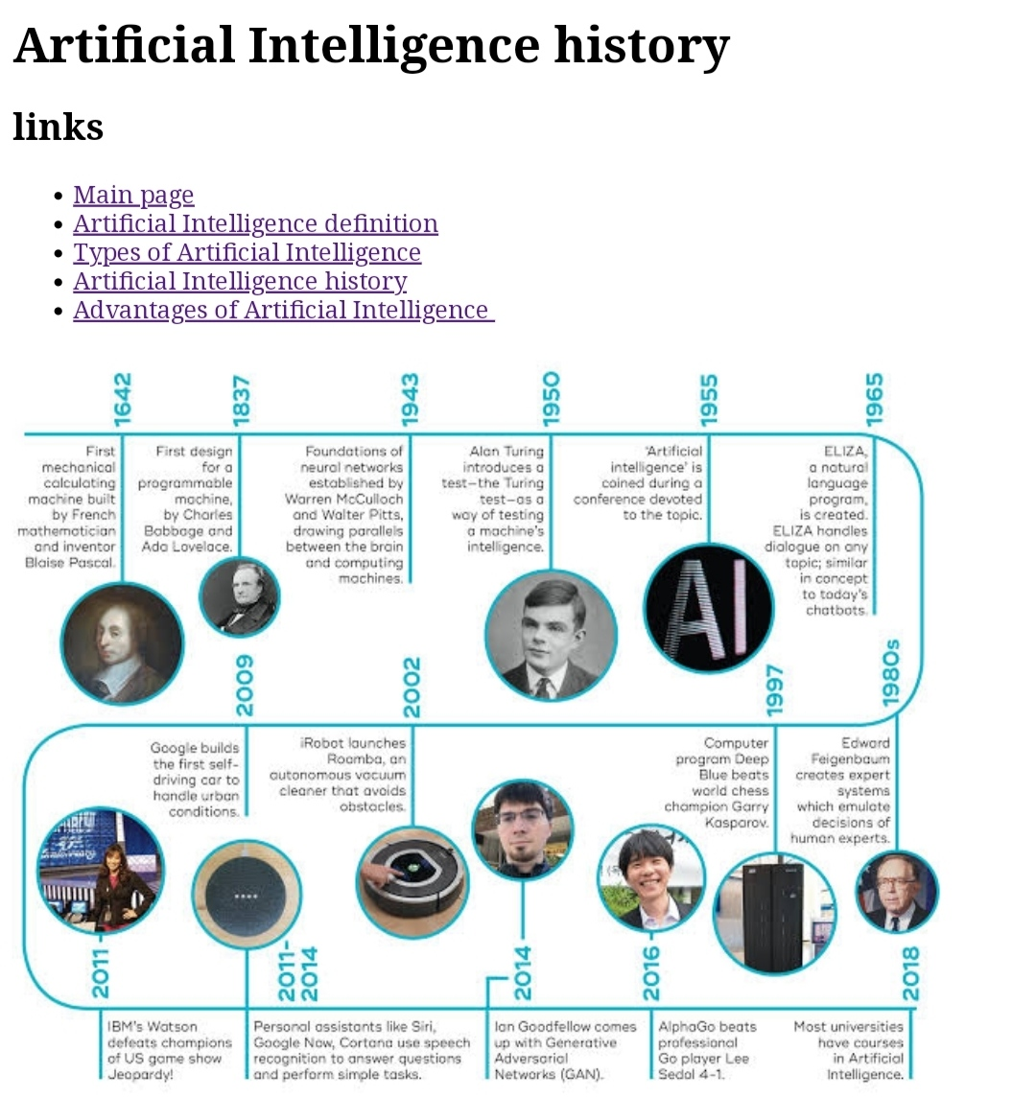

**Source code :**

